**Programming Assignment 4**

**Dennis Dang**

***MVC Description***

1. **Model:** The Model for this assignment is contained in its own class called Model.java. The Model contains the Calendar object and an ArrayList of Events. These two objects are shared by all views and must be accessed in order for the views to update themselves. The Views are updated whenever something in the Model is updated. The Model class also contains methods to load events from a text file at the start of the program, write events into a text file when the program exits and to check if a newly created event will conflict with existing events.
2. **View:** The two views are the MonthViewPanel and the DayViewPanel. The month view displays the entire month while the day view displays any scheduled events for the current day. Both of these views access the same data in the Model class. If there is a change in the Model, the Views are updated.
3. **Controller:** The Controllers are embedded in the MonthViewPanel and the DayViewPanel. They include the buttons that moves the calendar forward and backward, the JTable that displays the Calendar (where the user can change the current day by clicking on a day), the create an event button and the quit button. Activating any of these controllers will change some aspect of the Model. When the Model is changed, the Views are updated.

***Screen Shots***

**Screen 1**

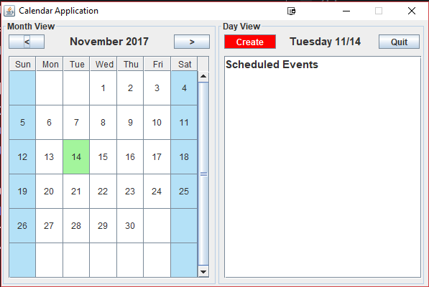

**Screen 2**

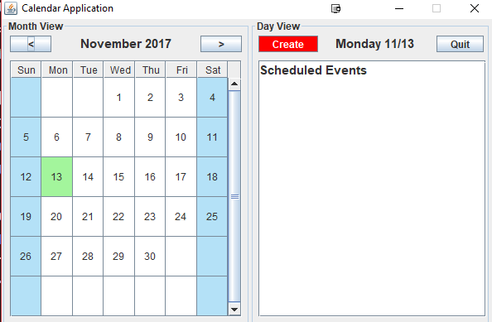

**Screen 3**

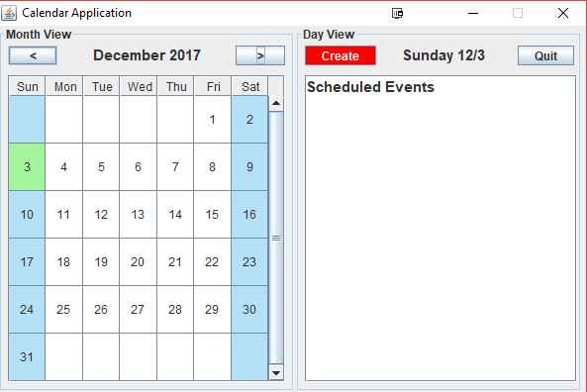

**Screen 4**

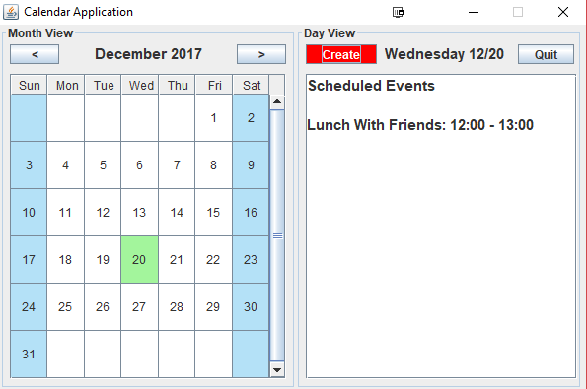

**Screen 5**

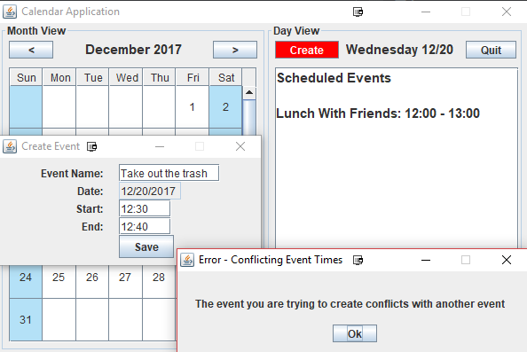

**Screen 6**

